Mishpacha Project
Introduction- Your family history is important! Every family is filled with stories that you should learn about and record. In our Jewish Studies course, we are beginning the Jewish life cycle. We are currently discussing the process and traditions associated with naming a Jewish child. You are being tasked with conducting an interview of your parents/family members. The purpose of this activity is for you to explore your family history. As we begin our journey through the Jewish life cycle, students are being asked to engage their families in discussion.

Due Dates
Part 1-Interview due September 27th (Check-in)
Part 2- Hebrew Name Research due October 3rd (Check-in)
Part 3- Presentation due October 8th (Check-in)

Final presentations begin October 10th, 2019
- Final copies of videos, posters, presentations need to be shared with Mr. Washerstein by this date

Part 1: Ask your parents/family members the following questions. Be sure to record their responses using the method of your choice (taking notes, voice-recording, video)

- How did you choose my name?
- Who was I named after?
- Do I have a Hebrew name that is different from my English name?
  - Did you research the meaning of my Hebrew name before you gave it me?
- Where are our family members originally from? (Trace your family history back as far as you can go!)
  - Has anyone in your family returned to visit their country/countries of origin?
  - Do you still have family who live there?
- Does our family consider ourselves/follow the traditions of the Ashkenazim, Sephardim, Mizrachim, or none of the above?
  - Provide some examples if possible
- How did we end up in Canada?
  - Why did our family members come to Canada? (if known)

Part 2: Students are required research the meaning of your Hebrew name.
- You will include the explanation of what your Hebrew name means in your presentation as well
- Do you believe the meaning of your Hebrew name connects to your personality? Explain why/why not.

Suggested websites for research:
  - https://www.behindthename.com
  - http://hebrewname.org
  - Depending on the name you may need to use other websites/reach out to your local Rabbi for help!

Part 3: Presenting your results
You have three choices for presenting your Mishpacha Project to the class:

Option 1- Create a slide show (either Google Slides or PowerPoint) answering the questions above
- One slide must be solely dedicated to explaining your name (who you were named for, meaning, etc.)
- Include pictures of your family, countries of origin, traditions
- Each question should be explained in detail during the presentation
- Please do not write full paragraphs on your slides…instead include bullet points with a key phrase/sentence (explain each phrase in detail during the presentation)

Option 2- Create a poster answering the questions above
- One area must be dedicated to explaining your name (who you were named for, meaning, etc)
- Include pictures of your family, countries of origin, traditions
- If you choose this option, please make sure your written text is big enough that your peers in the audience will be able to see it
- Each question should be explained in detail during the presentation

Option 3- Create a video answering the questions above
- One area must be dedicated to explaining your name (who you were named for, meaning, etc)
- Include pictures of your family, countries of origin, traditions.
- Each question should be explained in detail during the presentation
- Video must be edited thoroughly (add effects, music, transitions)

Presentation Content Rubric: Maximum of 40 points

- Level 4- Student sufficiently answers every question with high degree of detail and depth. 40 points
  - Each question is expanded upon.
  - Written work is thoroughly edited and free from spelling and grammar errors.
  - Presentation includes a picture for each question.

- Level 3- Student answers every question providing considerable detail and depth. 30 points
  - Each question is explained well, but there are some key details missing.
  - Written work is mostly edited and contains few spelling and grammar errors
  - Presentation includes pictures for most questions and colour.

- Level 2- Student answers every question providing some detail and depth.
  - Few questions are explained, and they are missing key information. (Use of one-word answers). 20 points
  - Written work is somewhat edited and contains many spelling and grammar errors.
  - Presentation includes pictures for some questions and colour.

- Level 1- Student answers question providing limited detail and depth and/or student fails to answer the majority of questions. 10 points
  - Questions are not answered entirely/and or missing
  - Written work requires a more careful edit as it contains a significant amount of spelling and grammar errors.
  - Presentation is missing multiple pictures
  - Presentation demonstrates a lack of effort

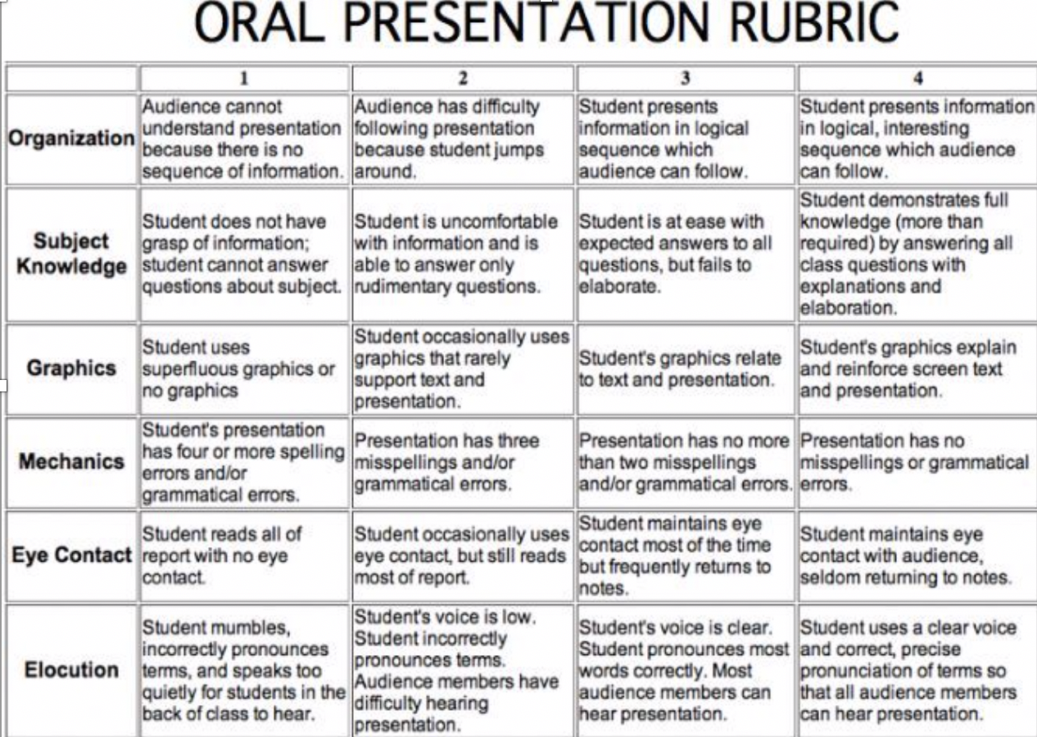
Oral Presentation Rubric: Maximum of 24 points

